Nama : - Afina Putri Dayanti (825200049)

* Eric Anthony (825200050)
* Aldi Resaldi (825200008)

Jurusan : Sistem Informasi

Mata Kuliah : Software Development

**Backlog**

Domain : <https://afinapd.backlog.com/projects/SUNTERRA>

Source : Sunterra Mobile App / <https://www.sunterra.id/>

1. Home

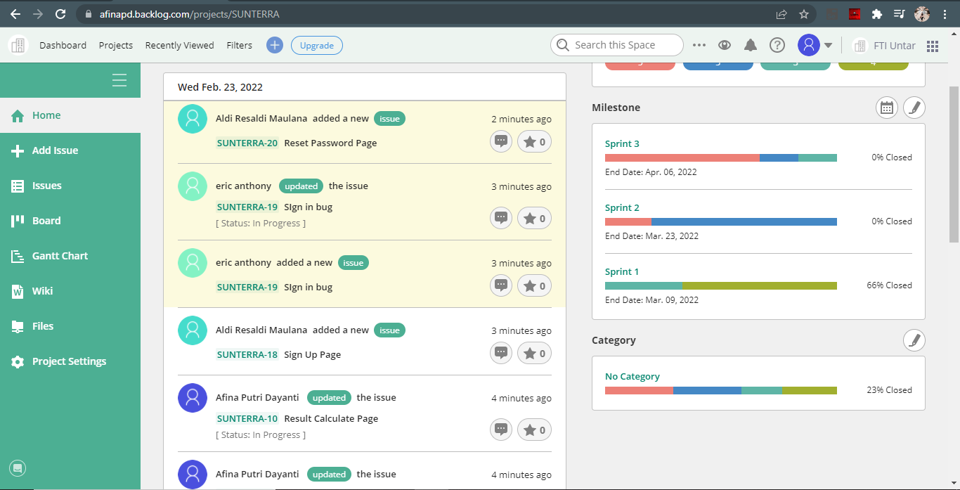

1. Issue

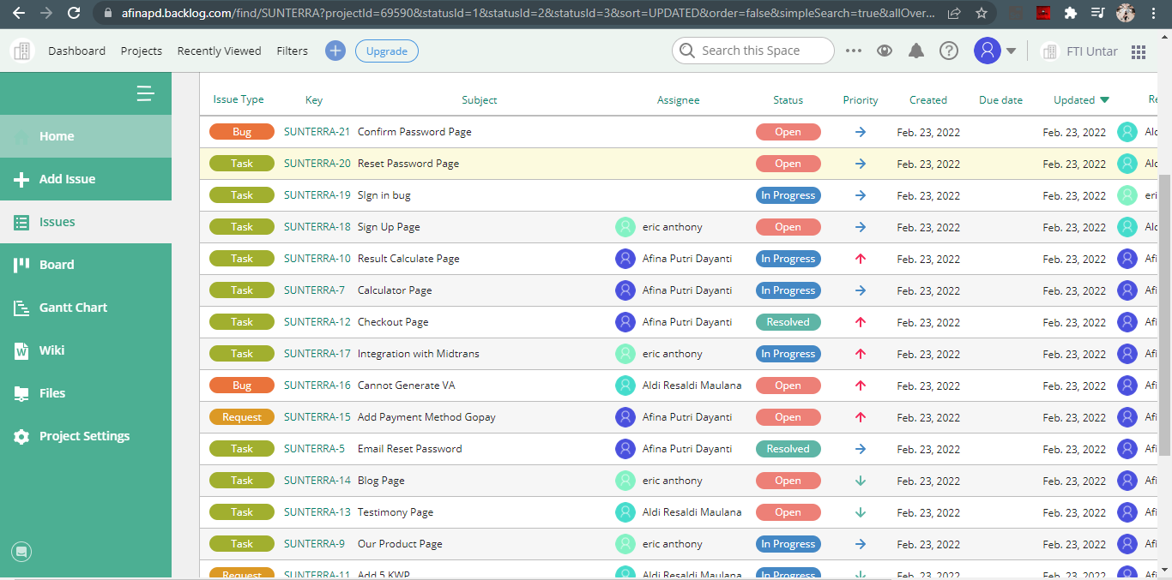

1. Board

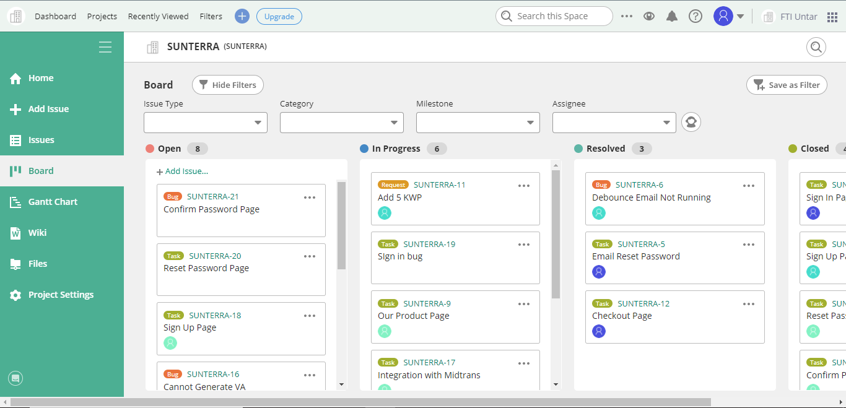

1. Version/Milestone

